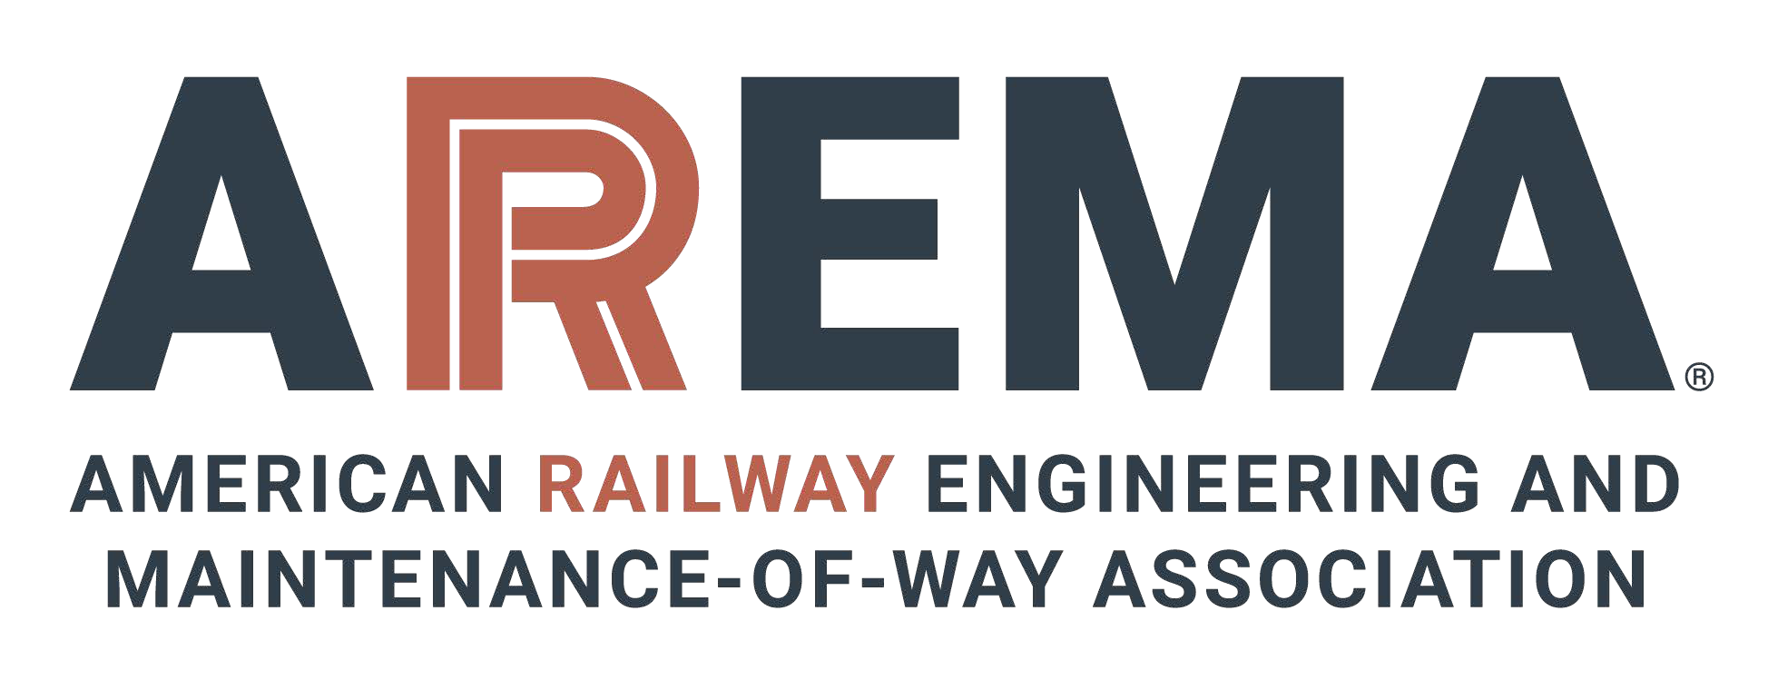

AREMA STUDENT CHAPTER CHARTER

ARTICLE I - PREAMBLE
Section 1.1 - As authorized by the Bylaws of the American Railway Engineering and Maintenance of-Way Association, hereinafter referred to as AREMA, this Charter is hereby granted for the Student Chapter of AREMA, hereinafter referred to as the Chapter.
Section 1.2 - The Charter shall be eﬀective beginning in 20 and shall remain in eﬀect, including any amendments, until rescinded by AREMA.
Section 1.3 - This Charter supersedes any previous charter or constitution of a Chapter enrolling members from the designated area and shall annul any Bylaws of such a Chapter which may be in conﬂict.

ARTICLE II - PURPOSE
Section 2.1 - The purpose of this Chapter shall be to promote the advancement of railway related engineering by fostering the close association of students with the railway engineering profession and AREMA; to acquaint students with topics of interest in railway engineering through the medium of competent speakers and of Chapter-sponsored trips; to foster the development of professional spirit; to promote common interests among students and to encourage the enhancement and optimization of facilities for railway engineering study.

ARTICLE III - CHAPTER GOVERNANCE
Section 3.1 - The Executive Board of the Chapter, composed of elected student oﬃcers and an AREMA Advisor, shall manage the aﬀairs of the Chapter in conformity with the provisions of this Charter, the bylaws of the Chapter and the policies of AREMA.
Section 3.2 - All elected student oﬃcers shall be AREMA Student members. President and Treasurer roles must be held by two diﬀerent individuals.
Section 3.3 - The AREMA Advisor shall hold the membership status of Associate Member of AREMA or higher.
Section 3.4 - Names and email addresses of all members of the Chapter Executive Board shall be reported in writing to the Student Chapter Coordinator within 30 days of taking their oﬃce.
Section 3.5 - The Chapter shall develop and adopt its own Bylaws to govern membership requirements, nomination and election process of oﬃcers, duties and responsibilities of each position on the Executive Board, assessment of fees and dues, method of amending Bylaws, and such other matters as the Chapter may desire, provided such Bylaws do not conﬂict with this Charter, the Bylaws of AREMA or policies of AREMA.
Section 3.6 - Chapter Bylaws shall not take eﬀect until ﬁled with and approved by the Student Chapter Coordinator and AREMA Director of Committee Services. At any time thereafter, AREMA may annul any part of the Chapter's Bylaws, which it considers to be contrary to the AREMA Bylaws or to the best interests of AREMA, by giving notice in writing to the Chapter Executive Board.

ARTICLE IV - CHAPTER REQUIREMENTS
Section 4.1 - The Chapter must have a minimum of 5 AREMA student members aﬃliated with the university.
Section 4.2 - The Chapter must conduct at least three (3) Railroad Events per semester, or at least six
(6) per calendar year if the university is not on a semesterly system. Railroad Events are deﬁned as events that include railroad industry presentations, student or faculty presentations on a railroad topic, railroad industry ﬁeld trips or volunteering events, networking events with railroad industry professionals present, and attendance of AREMA conferences and symposiums. Other events may be approved as Railroad Events if given prior written approval by the Student Chapter Coordinator. Internal chapter business meetings and executive board meetings do not qualify as Railroad Events.
Section 4.3 - A student delegate of the Chapter shall participate in three of approximately four scheduled Student Chapter Coordination Calls per calendar year. When the student delegate is unable to attend, a substitute must be assigned. The Chapter’s Advisor is encouraged to attend Student Chapter Coordination Calls but not required to. A minimum 30-day notice shall be provided by the Student Chapter Coordinator to schedule Student Chapter Coordination Calls.
Section 4.4 - The Chapter shall maintain records for all Chapter ﬁnances. An annual budget shall be adopted by the Executive Board of the Chapter.
Section 4.5 - The Chapter shall submit a written annual report to the AREMA Student Chapter Coordinator no later than January 15th, documenting conformance with the Student Chapter Charter. The Annual Report shall be utilized by AREMA to determine whether the chapter is in Good Standing.
Section 4.6 - If, in the judgment of AREMA, a Chapter is not in good standing for two or more consecutive years, AREMA may declare that Chapter inactive. Should a Chapter be declared inactive, it shall not be eligible to receive annual AREMA funding or to act collectively in the name of AREMA. All existing AREMA student members shall remain AREMA student members at large, and the Student Chapter may be reinstated by submission and AREMA approval of the same documentation required for chartering a new Chapter.

ARTICLE V - RELATIONSHIP OF CHAPTER TO AREMA
Section 5.1 - The Chapter shall not assume to speak for AREMA unless authorized in the particular matter in question by the AREMA Director of Committee Services.
Section 5.2 - AREMA will not be responsible for debts contracted by the Chapter. The Chapter does not have the authority to commit AREMA contractually or ﬁnancially.
Section 5.3 - No dues or fees will be required to be paid by the Chapter to AREMA.
Section 5.4 - AREMA reserves the right to make amendments to this Charter. AREMA will notify the Chapter’s Executive Board of amendments for review and execution.

ARTICLE VI - DISSOLUTION
Section 6.1 - In the event of the dissolution of the Chapter, any funds remaining in the Chapter operating fund shall ﬁrst be used to pay any remaining obligations. After obligations, any remaining funds are returned to AREMA.

SUBSCRIBED FOR AREMA

Chapter President:

AREMA Advisor:

Date:

